Hotel Database – JOIN Queries

1. Display hotel ID, name, and the name of its manager.
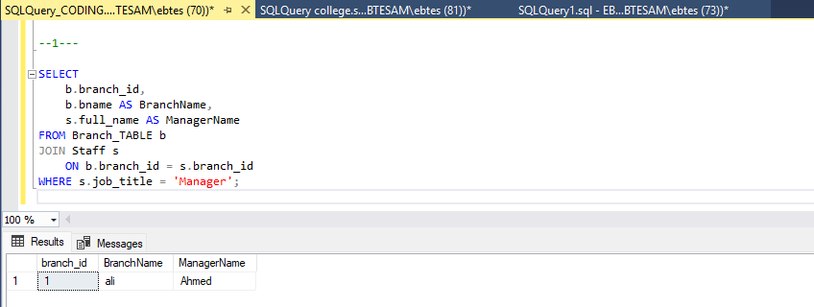
2. Display hotel names and the rooms available under them.
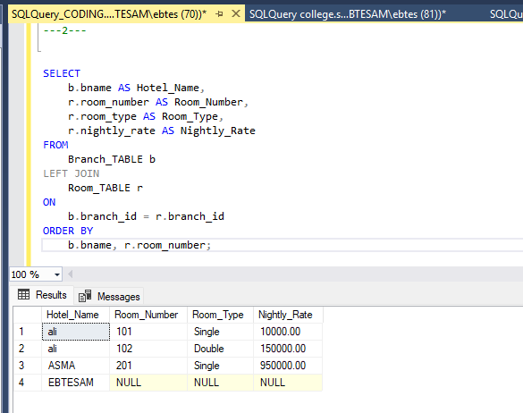

3. Display guest data along with the bookings they made.
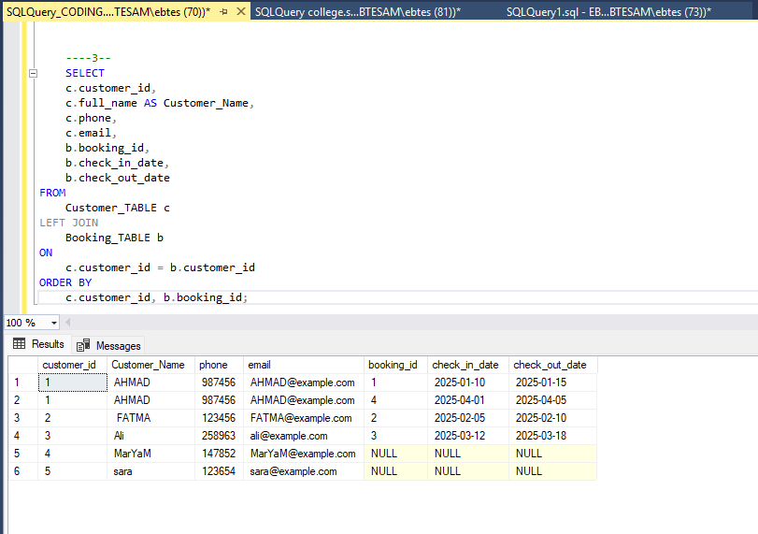
4. Display bookings for hotels in 'Hurghada' or 'Sharm El Sheikh'.
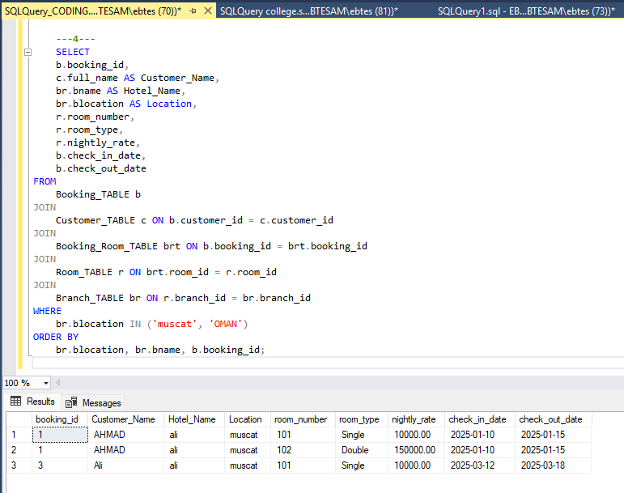
5. Display all room records where room type starts with "S" (e.g., "Suite", "Single").
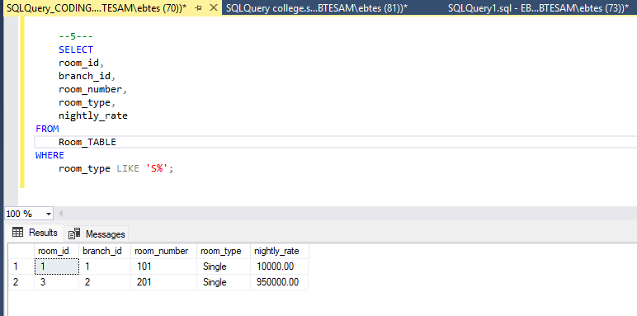
6. List guests who booked rooms priced between 1500 and 2500 LE.
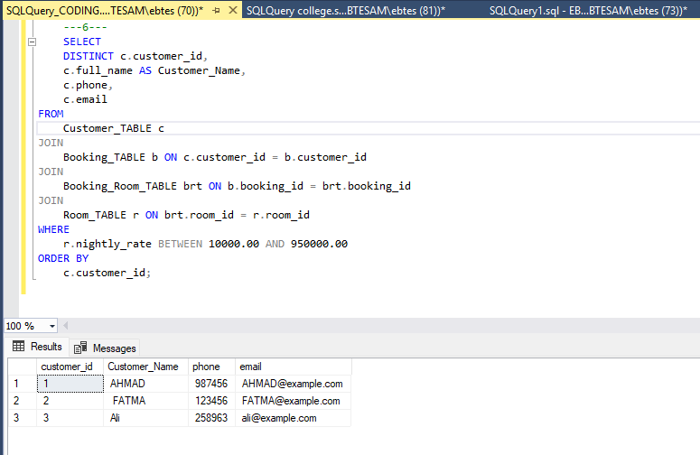

7. Retrieve guest names who have bookings marked as 'Confirmed' in hotel "Hilton
Downtown".
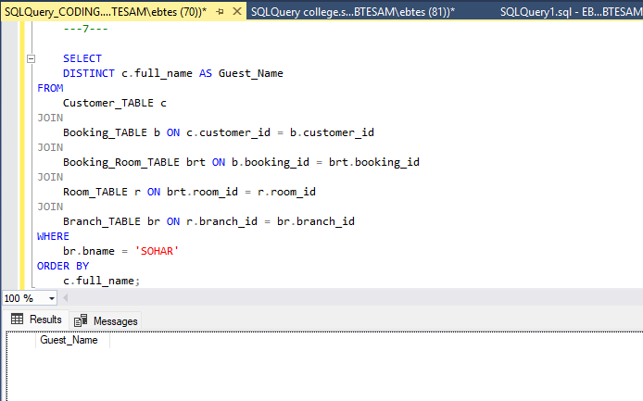
8. Find guests whose bookings were handled by staff member "Mona Ali".
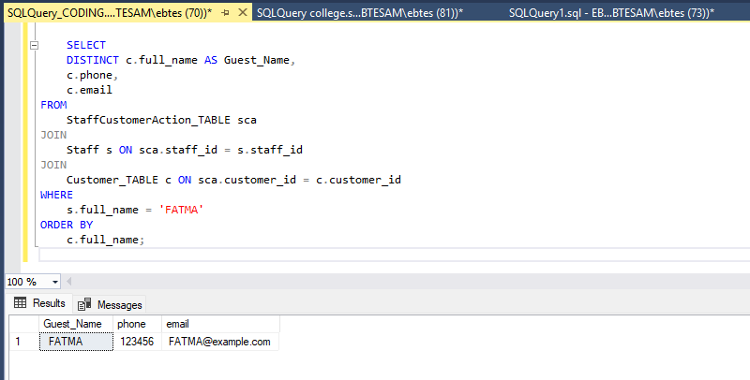
9. Display each guest’s name and the rooms they booked, ordered by room type.
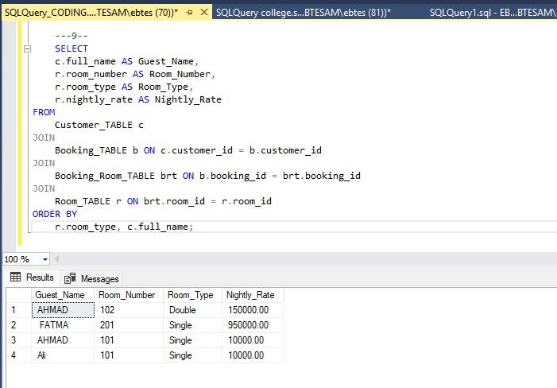
10. For each hotel in 'Cairo', display hotel ID, name, manager name, and contact info.
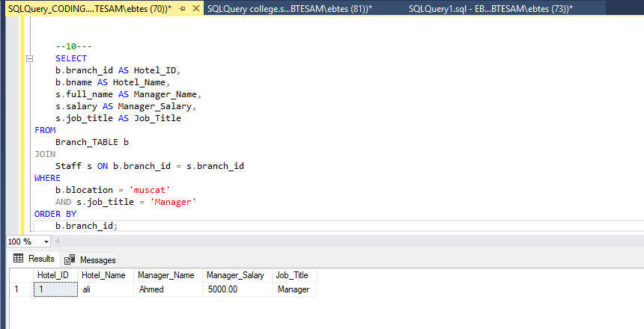

11. Display all staff members who hold 'Manager' positions.
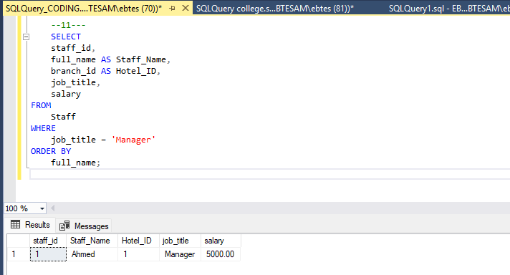
12. Display all guests and their reviews, even if some guests haven't submitted any reviews
